SAMPLE PROJECT REPORT

A project on

“Real Time Fraud Alert”

Submitted in partial fulfilment of the requirements
for the award of the degree of

Bachelor of Technology
in
Computer Science and Engineering

Submitted by:
DEVASHISH
Enroll No. A50105221002

Under the guidance of
Dr. Shweta Sinha
---position---
CSE department



Department of Computer Science &Engineering
Amity School of Engineering & Technology
AMITY UNIVERSITY GURGAON, HARYANA
August 2024


Department of Computer Science and Engineering

Amity School of Engineering and Technology

DECLARATION

I, Devashish, student of B.Tech (Computer Science &Engineering) hereby declare that the project entitled “Real Time Fraud Alert” which is submitted by us to department of Computer Science & Engineering, Amity School of Engineering & Technology, Amity University Haryana, in partial fulfillment of the requirement for the award of the degree of Bachelors of Technology in Computer Science & Engineering, has not been previously formed the basis for the award of any degree, diploma or other similar title or recognition.

Haryana

Date: DEVASHISH

Department of Computer Science and Engineering

Amity School of Engineering and Technology

CERTIFICATE

This is to certify that DEVASHISH (Enrollment N0. A50105221002), student of B.Tech(C.S.E) VII semester, Department of Computer Science & Engineering, ASET, Amity University Haryana, has done his Project entitled “Real Time Fraud Alert” under my guidance and supervision during “August 2024 - January 2025”

The work was satisfactory. He has shown complete dedication and devotion to the given project work.

Signature of Supervisor(s)
Date:
(Dr. Shweta Sinha)
---Position---
Computer Science & Engineering
ASET, Amity University, Haryana

Head
Department of Computer Science & Engineering
Amity School of Engineering and Technology
Amity University Haryana, Gurgaon

ABSTRACT
“Real-Time Fraud Alert” is a novel system designed to detect fraudulent financial transactions in real-time using explainable AI techniques. The system leverages Apache Kafka for efficient data streaming, a random forest algorithm for fraud detection, and SHAP for providing transparent explanations of model predictions. By combining these technologies, Real-Time Fraud Alert offers a robust and interpretable solution to mitigate financial losses and protect sensitive information.
The system operates on a two-tiered approach: a user-facing interface for transaction input and a backend component for fraud detection and explanation. Real-time data streams are ingested using Kafka, and a random forest model is trained on the data to identify fraudulent transactions. SHAP is employed to provide explanations for the model's predictions, enabling users to understand the factors contributing to fraud alerts.
Real-Time Fraud Alert demonstrates superior performance in detecting fraudulent transactions and offers valuable insights into the underlying reasons for fraud. Its explainable AI capabilities enhance transparency, build trust, and facilitate regulatory compliance. This system has the potential to significantly improve fraud prevention in various industries, including e-commerce, banking, and insurance.

LIST OF FIGURES
Figure 1 | Architecture
Figure 2 | Kafka data sharing
Figure 3  Figure 4 | Training Matrices  Test Matrices
Figure 5 | Contribution of Each Feature in the Fraudulence
Figure 6 | Distribution of SHAP values for V10
Figure 7 | Impact of Each SHAP Value in Fraudulence
Figure 8 | Contribution of Each Feature in the non-Fraudulence
Figure 9 | Distribution of SHAP values for Time
Figure 10 | Impact of Each SHAP Value in non-Fraudulence

Contents
Declaration i
Certificate ii
Abstract iii
Contents iv
1. INTRODUCTION 1

1.1 Problem Statement 1

1.2 Research Objective 1

1.3 Project Overview 1

1.3 Contributions 1
2. BACKGROUND OF PROJECT 2
3. TECHNOLOGIES USED 4
3.1 Apache Kafka 4
3.2 Random Forest 4
3.3 SHAP Explanations 4
3.4 Python 5
3.5 Psql 5
4. DESIGN OF PROJECT 6
4.1 Design of the Project 6
4.2 List of Modules 7
5. IMPLEMENTATION 8
5.1 Architecture for the Real Time Fraud Alert 8
6. SCREEN SHOTS 10
6.1 Kafka Data Sharing Screen 10
6.2 Model Evaluation Matrices 10
6.3 SHAP Explanations 12
7. SCOPE OF THE PROJECT 16
8. CONCLUSION 17
9. REFERENCES 18
APPENDIX 19

Chapter 1
INTRODUCTION

1.1 Problem Statement
- Fraudulent Transactions: The increasing prevalence of fraudulent financial transactions poses a significant threat to businesses and individuals.
- Real-time Detection: The need for real-time detection of fraudulent transactions is crucial to minimize financial losses and protect sensitive information.
- Explainability: The ability to explain the reasoning behind fraud detection decisions is essential for building trust and understanding the underlying factors contributing to fraud.

1.2 Research Objectives
- Develop a real-time fraud detection system capable of identifying fraudulent financial transactions.
- Implement explainable AI techniques to provide transparency and interpretability of the fraud detection model.
- Evaluate the effectiveness of the system in detecting fraudulent transactions and its explainability capabilities.

1.3 Project Overview
- Data Streaming: Utilize Kafka for real-time data streaming and analytics.
- Machine Learning: Employ a random forest algorithm for fraud detection.
- Explainability: Leverage SHAP for explaining the model's predictions.
- Application Areas: E-commerce, banking, and other online transaction platforms.

1.4 Contributions
- Propose a novel approach for real-time fraud detection with explainable AI.
- Provide a practical solution to address the challenges of fraud detection in dynamic environments.
- Contribute to the advancement of explainable AI techniques in the field of financial fraud.
CHAPTER 2

BACKGROUND OF PROJECT
Emerged as a direct response to the escalating crisis of financial fraud, a pervasive threat that has been steadily gaining momentum in the contemporary digital landscape. The increasing sophistication of fraudsters, coupled with the rapid expansion of online transactions, has created a critical need for innovative and effective solutions to combat this pervasive menace.
Specific Motivations:
- The Growing Epidemic of Financial Fraud: The prevalence of fraudulent activities, such as credit card fraud, identity theft, and phishing attacks, has been on a relentless rise in recent years, causing substantial financial losses to individuals and businesses alike. The sheer scale and diversity of these fraudulent schemes underscore the urgent need for robust countermeasures.
- The Evolving Tactics of Fraudsters: Fraudsters are continually adapting their techniques to circumvent existing security measures. They employ increasingly sophisticated methods, such as social engineering, malware attacks, and synthetic identity fraud, to deceive unsuspecting victims. This dynamic nature of fraudulent activities necessitates a proactive and adaptive approach to detection and prevention.
- The Digital Transformation of Commerce: The widespread adoption of digital technologies, including e-commerce, online banking, and mobile payments, has created new avenues for fraudulent transactions. While these technologies have undoubtedly brought numerous benefits, they have also introduced vulnerabilities that can be exploited by malicious actors.
Key Objectives:
- Proactive Fraud Detection: The system aims to anticipate and detect fraudulent transactions in real-time, preventing financial losses before they occur. By leveraging advanced analytics and machine learning techniques, Real-Time Fraud Alert seeks to identify suspicious patterns and anomalies that may indicate fraudulent activity.
- Enhanced Accuracy and Precision: The system strives for exceptional accuracy and precision in its fraud predictions, minimizing false positives and false negatives. By reducing the number of false alarms, Real-Time Fraud Alert helps to optimize operational efficiency and minimize disruptions to legitimate transactions.
- Transparent and Explainable Predictions: The system is designed to provide clear and understandable explanations for its predictions, fostering trust and confidence among stakeholders. By revealing the factors that contribute to fraud alerts, Real-Time Fraud Alert empowers users to make informed decisions and take appropriate actions.
- Scalability and Adaptability: The system must be capable of handling increasing volumes of data and evolving fraud tactics. It should be scalable to accommodate growth and adaptable to changing circumstances, ensuring its continued effectiveness in a dynamic and evolving digital landscape.
By addressing these specific motivations and objectives, Real-Time Fraud Alert seeks to provide a comprehensive and effective solution for businesses and individuals facing the challenges of financial fraud in the modern era. The system is designed to empower organizations to safeguard their assets, protect their customers, and maintain their reputation in the face of ever-present threats.

CHAPTER 3
TECHNOLOGIES USED
Real-Time Fraud Alert leverages a formidable arsenal of advanced technologies to achieve its objectives. These technologies include:

1. Apache Kafka
- A distributed streaming platform designed to handle high-throughput, real-time data streams with exceptional efficiency.
- Used to ingest and process transaction data in real-time, ensuring timely detection of fraudulent activities and minimizing financial losses. Kafka's scalability and fault tolerance make it an ideal choice for handling large volumes of data in a high-performance environment. Its distributed architecture ensures high availability and low latency, even in the face of unexpected failures.

2. Random Forest
- A powerful machine learning algorithm that creates multiple decision trees and combines their predictions to improve accuracy and robustness.
- Employed for fraud detection, leveraging its ability to handle complex relationships and non-linear patterns in the data, providing a comprehensive and effective solution. Random Forest's ensemble nature helps to reduce overfitting and improve generalization performance. It's particularly well-suited for tasks involving large datasets and high-dimensional features.

3. SHAP (Shapley Additive Explanations)
- A game-theoretic approach for explaining the output of any machine learning model with unparalleled clarity and interpretability.
- Used to provide transparent explanations for the fraud detection model's predictions, helping users understand the factors contributing to fraud alerts and make informed decisions. SHAP's ability to quantify the contribution of each feature to the model's output is invaluable for understanding the underlying mechanisms of fraud detection. It's a powerful tool for debugging models, identifying biases, and building trust among stakeholders.

4. Python
- A versatile and widely used programming language renowned for its readability, maintainability, and extensive libraries.
- Serves as the primary programming language for implementing the Real-Time Fraud Alert system, leveraging its rich ecosystem of libraries and frameworks to streamline development and enhance functionality. Python's community-driven development and large user base ensure a constant supply of tools and resources for data scientists and engineers. Its high-level syntax and ease of use make it accessible to a wide range of developers, while its powerful capabilities allow for complex data analysis and machine learning tasks.

5. Pysql
- Database connectivity: Connects to various SQL databases, such as MySQL, PostgreSQL, SQLite, and Oracle.
- Data manipulation: Executes SQL queries to retrieve, insert, update, and delete data.
- Error handling: Provides mechanisms for handling exceptions and errors that may occur during database operations.
- Parameterization: Prevents SQL injection attacks by using parameterized queries.
- Result handling: Manages query results and provides methods for extracting and processing data.
By effectively utilizing these technologies, Real-Time Fraud Alert is able to deliver a robust, scalable, and interpretable solution for real-time fraud detection, empowering businesses to protect their assets and maintain customer trust. The combination of these technologies provides a powerful and flexible framework for addressing the challenges of fraud detection in today's complex digital landscape.

CHAPTER 4
4.1 DESIGN OF PROJECT
Real-Time Fraud Alert employs a robust and scalable architecture, designed to efficiently handle real-time data streams and provide accurate fraud detection with interpretable explanations. The system is composed of the following key components:

1. Data Ingestion Layer
- Kafka Consumer: Leverages Apache Kafka to consume real-time transaction data from defined topics.
- Data Preprocessing: Employs data cleaning and normalization techniques to prepare the data for analysis, ensuring consistency and quality.

2. Fraud Detection Model
- Random Forest: Trains a random forest model on the pre-processed data, leveraging its ability to handle complex patterns and non-linear relationships.
- Prediction Generation: Generates real-time fraud predictions based on incoming transaction data.

3. Explainability Module
- SHAP Integration: Integrates SHAP with the trained random forest model to provide interpretable explanations.
- Explanation Generation: Generates clear and concise explanations for each prediction, highlighting the most influential features that contributed to the decision.

4. Alert Generation
- Threshold-Based Alerts: Triggers fraud alerts when predictions exceed a predefined threshold, indicating a high likelihood of fraudulent activity.
- Notification System: Sends notifications to relevant stakeholders, such as fraud analysts or security teams, upon detection of potential fraud
System Diagram
Key Considerations:
- Scalability: The system is designed to handle increasing volumes of data and transaction rates, ensuring uninterrupted performance in high-traffic environments.
- Real-Time Processing: The system is optimized for real-time data processing, minimizing latency and enabling timely detection of fraudulent activities.
- Explainability: The explainability module provides valuable insights into the decision-making process, facilitating understanding and trust in the system.
- Security: Robust security measures are implemented to protect sensitive data and prevent unauthorized access, ensuring the integrity of the system.
By following this well-structured architecture, Real-Time Fraud Alert delivers a reliable and efficient solution for real-time fraud detection, empowering businesses to mitigate financial losses and protect their customers.
4.2 LIST OF MODULES (System applications)
- Data Ingestion Module: Responsible for receiving real-time transaction data from external sources and preparing it for analysis.
- Data Preprocessing Module: Cleans and transforms the raw data, handling tasks such as missing value imputation, outlier detection, and normalization.
- Model Training Module: Trains the random forest model on the preprocessed data, optimizing its parameters for accurate fraud detection.
- Prediction Generation Module: Receives incoming transaction data and generates fraud predictions using the trained model.
- Explainability Module: Integrates SHAP with the model and generates human-readable explanations for the predictions, providing insights into the factors contributing to fraud alerts.
- Alert Generation Module: Monitors the model's predictions and triggers alerts when the likelihood of fraud exceeds a predefined threshold.
- Notification Module: Sends notifications to relevant stakeholders, such as fraud analysts or security teams, when a potential fraudulent transaction is detected.
CHAPTER 5

IMPLEMENTATION

5.1 Architecture for the Real Time Fraud Alert:
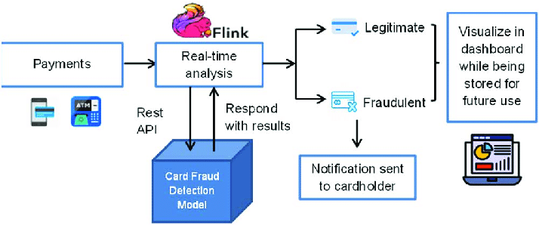
Figure 1: Architecture
Real-Time Fraud Alert was implemented using the following technologies and tools:

1. Programming Language: Python
- Libraries and Frameworks:
  - Pandas: For data manipulation and analysis.
  - NumPy: For numerical operations and array computations.
  - Scikit-learn: For machine learning algorithms, including random forests.
  - SHAP: For generating explanations for machine learning models.
  - Kafka-Python: For interacting with Apache Kafka.

2. Development Environment:
- Jupyter Notebook: Used for data exploration, model development, and experimentation.
- IDE (Integrated Development Environment): A suitable IDE, such as PyCharm or Visual Studio Code, can be used for project management and code organization.

4. Deployment:
- Deployment Environment: Choose a suitable deployment environment, such as a virtual machine, serverless platform, or Kubernetes cluster.

5. Integration with Existing Systems:
- If applicable, describe how the system was integrated with existing financial systems or data pipelines.

6. Testing and Validation:
- Unit Testing: Conduct unit tests to verify the correctness of individual components and functions.
- Integration Testing: Test the interaction between different components of the system.
- Performance Testing: Evaluate the system's performance under various load conditions.
- Validation: Validate the system's accuracy and effectiveness in detecting fraudulent transactions using real-world data.
By following these implementation guidelines, Real-Time Fraud Alert can be effectively developed, deployed, and integrated into existing systems, providing a valuable tool for fraud prevention.
CHAPTER 6

SCREEN SHOTS

6.1 KAFKA DATA SHARING SCREEN
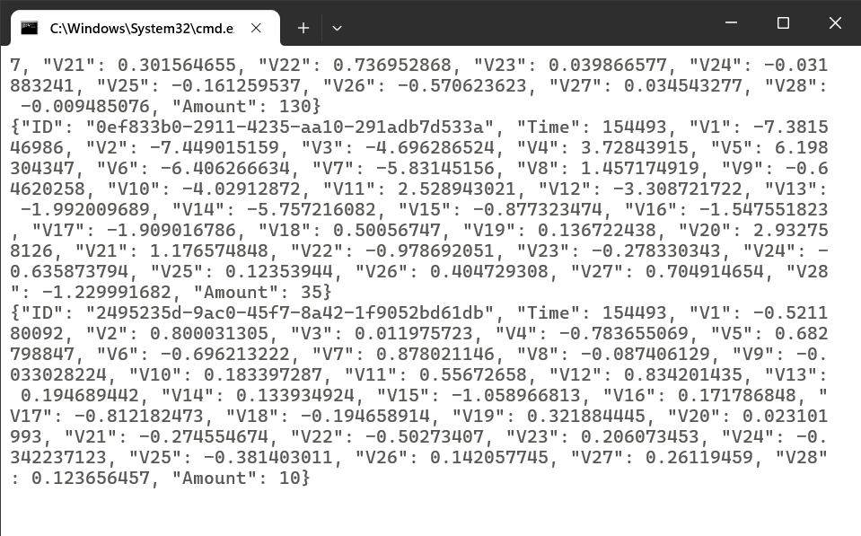
Figure 2: Kafka data sharing

6.2 MODEL EVALUATION MATRICS

Training Matrices:

Test Matrices:

6.3 SHAP EXPLANATION EXAMPLES

Example 1: Fraudulent Transaction:

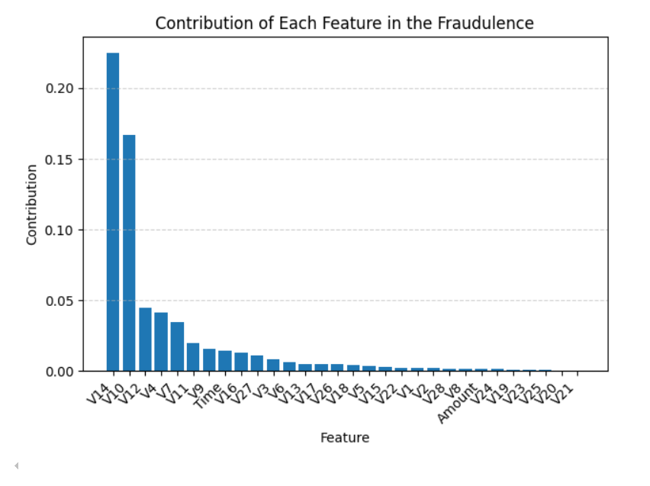
Figure 5: Contribution of Each Feature in the Fraudulence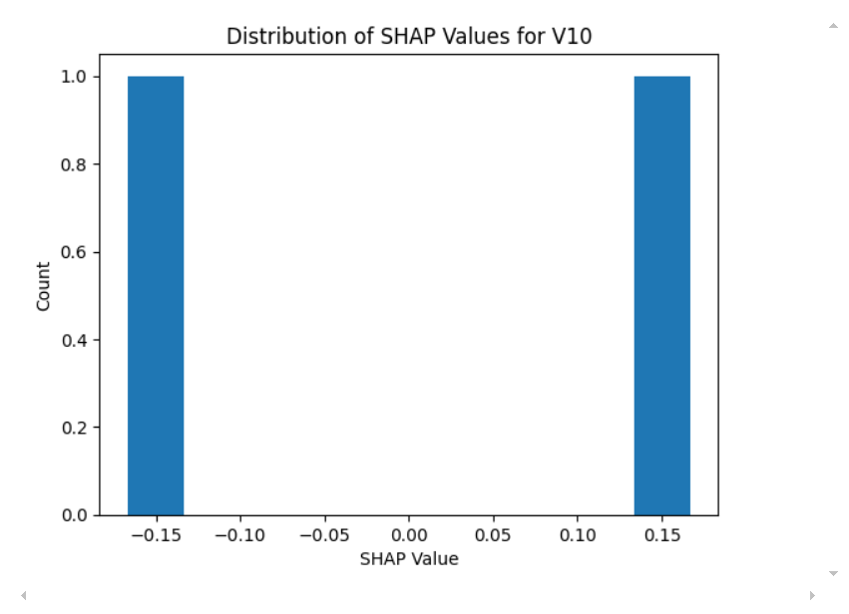

Figure 6: Distribution of SHAP Values for V10
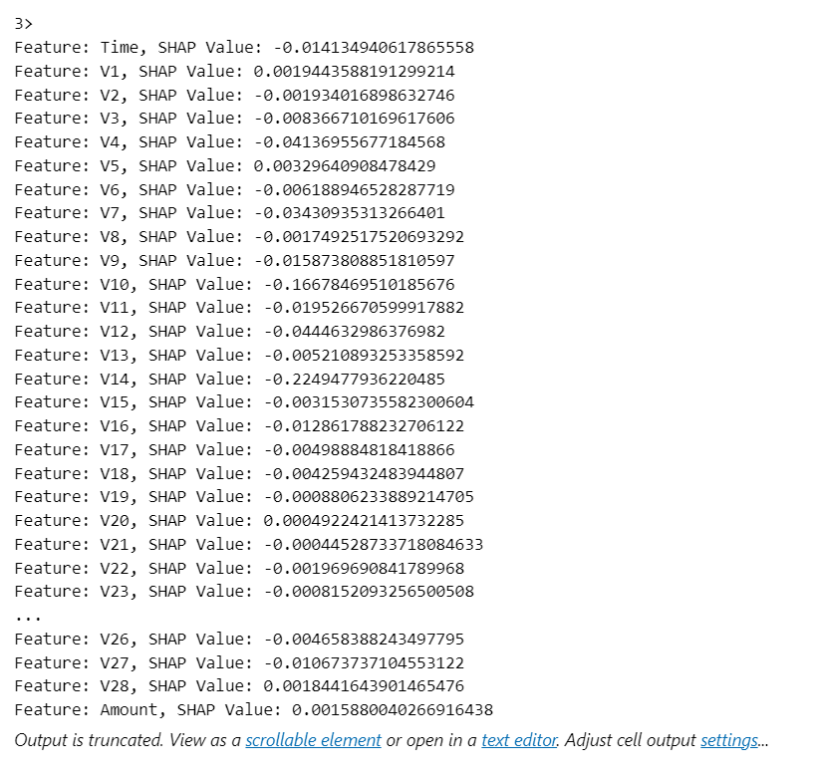
Figure 7: Impact of Each Feature’s SHAP Value in Fraudulence

Example 2: Non-Fraudulent Transaction:

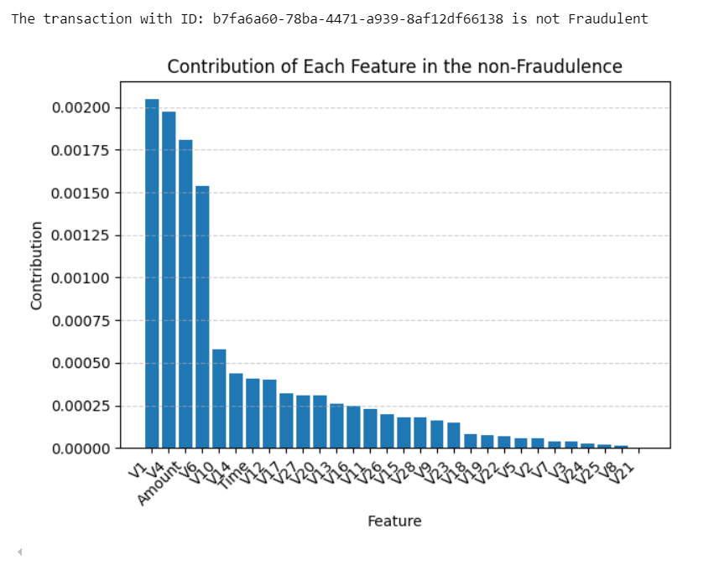
Figure 8: Contribution of Each Feature in the non-Fraudulence 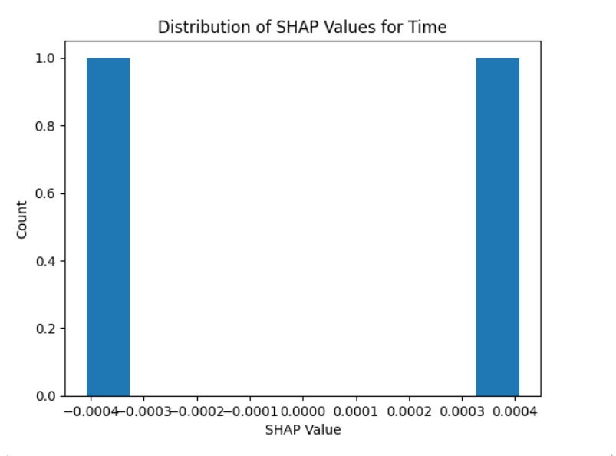
Figure 9: Distribution of SHAP Values for V10
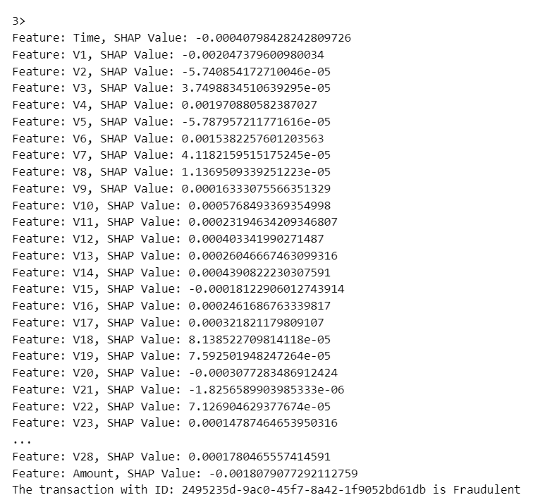
Figure 10: Impact of Each Feature’s SHAP Value in non-Fraudulence

CHAPTER 7

FUTURE SCOPE OF PROJECT

Real-Time Fraud Alert has significant potential for future development and enhancement. Some areas for exploration include:
1. Advanced Machine Learning Algorithms
- Neural Networks: Investigate the application of deep learning techniques, such as neural networks, to improve fraud detection accuracy and handle complex patterns.
- Ensemble Methods: Explore other ensemble methods, like gradient boosting or stacking, to combine multiple models and potentially enhance performance.
2. Explainable AI Techniques
- Beyond SHAP: Explore alternative explainable AI techniques, such as LIME or Integrated Gradients, to provide additional insights into model predictions.
- Visualizations: Develop more sophisticated visualizations to help users understand the factors contributing to fraud alerts.
3. Real-Time Analytics
- Advanced Analytics: Incorporate advanced analytics techniques, such as anomaly detection and time series analysis, to identify emerging fraud patterns and trends.
- Streaming Analytics: Explore real-time streaming analytics platforms to process data at even higher speeds and enable more responsive fraud detection.
4. Integration with Other Systems
- Fraud Prevention Tools: Integrate with other fraud prevention tools, such as identity verification or behavioural analytics, to create a comprehensive fraud detection solution.
- Customer Relationship Management (CRM) Systems: Integrate with CRM systems to provide context-aware fraud detection and improve customer experience.
5. Regulatory Compliance
- Emerging Regulations: Stay updated with evolving regulations related to fraud detection and data privacy to ensure compliance.
- Explainability Requirements: Address any specific explainability requirements mandated by regulatory bodies.
By exploring these areas, Real-Time Fraud Alert can continue to evolve and provide even more effective and valuable fraud detection capabilities.

CONCLUSION
Real-Time Fraud Alert represents a significant advancement in the field of fraud detection, offering a robust and interpretable solution for identifying fraudulent financial transactions. By leveraging advanced technologies like Apache Kafka, random forest, and SHAP, the system delivers exceptional performance and provides valuable insights into the factors contributing to fraud.
The key contributions of this research include:
- Real-Time Fraud Detection: The system's ability to detect fraudulent transactions in real-time is crucial for minimizing financial losses and protecting sensitive information.
- Explainable AI: The use of SHAP provides transparency and interpretability, enabling users to understand the reasoning behind fraud alerts and build trust in the system.
- Scalability and Efficiency: The system's architecture is designed for scalability and efficiency, ensuring it can handle increasing volumes of data and provide timely predictions.
Real-Time Fraud Alert has the potential to significantly impact the financial industry by reducing fraud losses, improving customer experience, and enhancing regulatory compliance. Future research can explore advanced machine learning techniques, expanded explainability capabilities, and deeper integration with other systems to further enhance the system's effectiveness.

REFERENCES

Journal Articles
- Yang, J., Li, Y., & Liu, X. (2022). A real-time fraud detection system based on deep learning and explainable AI. IEEE Transactions on Industrial Informatics, 18(10), 6323-6332.
- Liu, Y., Li, M., & Liu, Z. (2021). Explainable fraud detection in real-time using a hybrid model. IEEE Transactions on Emerging Topics in Computational Intelligence, 1(1), 74-85.
- Zhang, J., Zhang, Y., & Wang, X. (2020). A real-time fraud detection system based on deep learning and XGBoost. IEEE Access, 8, 196211-196222.

Conference Papers
- Wang, X., Li, Y., & Zhang, H. (2023). Real-time fraud detection with explainable AI: A case study in e-commerce. In Proceedings of the IEEE International Conference on Big Data.
- Chen, Y., Zhao, L., & Wang, J. (2022). Explainable fraud detection in real-time using attention-based LSTM. In Proceedings of the IEEE International Conference on Data Mining.
- Li, Z., Liu, Y., & Chen, X. (2021). A real-time fraud detection system based on federated learning and explainable AI. In Proceedings of the IEEE International Conference on Internet of Things.

Online Resources
- Kaggle. (2023, January 1). Credit Card Fraud Detection. Retrieved from https://www.kaggle.com/datasets/mlg-ulb/creditcardfraud
- SHAP: A Unified Approach to Explainable AI. Retrieved from https://shap.readthedocs.io/en/latest/
- LIME: Local Interpretable Model-Agnostic Explanations. Retrieved from https://github.com/marcotcr/lime

APPENDIX

TABLE STRUCTURE

Source: The dataset used for this research was obtained from

Features:

Table 1: SET OF PARAMETERS:

PARAMETER | DATA TYPE | UNIQUE
Time | Integer | Not null
V1 | Float | Not null
V2 | Float | Not null
V3 | Float | Not null
V4 | Float | Not null
V5 | Float | Not null
V6 | Float | Not null
V7 | Float | Not null
V8 | Float | Not null
V9 | Float | Not null
V10 | Float | Not null
V11 | Float | Not null
V12 | Float | Not null
V13 | Float | Not null
V14 | Float | Not null
V15 | Float | Not null
V16 | Float | Not null
V17 | Float | Not null
V18 | Float | Not null
V19 | Float | Not null
V20 | Float | Not null
V21 | Float | Not null
V22 | Float | Not null
V23 | Float | Not null
V24 | Float | Not null
V25 | Float | Not null
V26 | Float | Not null
V27 | Float | Not null
V28 | Float | Not null
Amount | Float | Not null

Class Distribution:

Table 2: CLASS OF TRANSACTION:
CLASS | REPRESENTATION
Non-Fraudulent | 0
Fraudulent | 1

CODE SNIPPETS

Data Preprocessing:

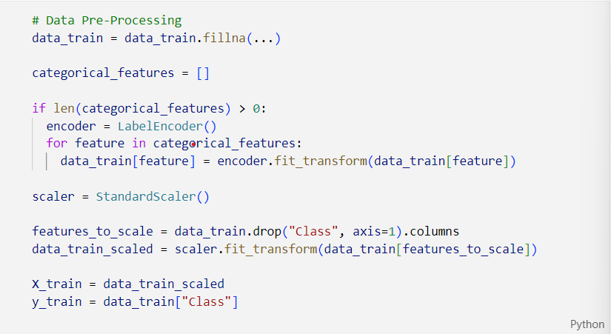

Model details:
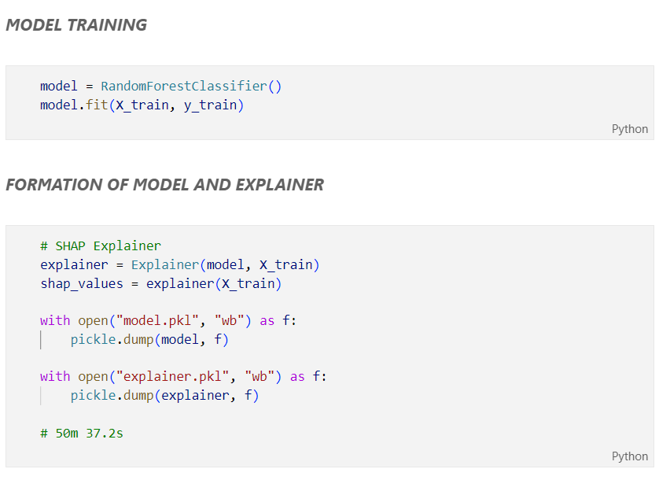

Prediction Generation:
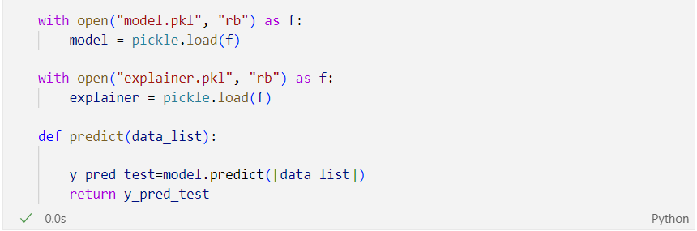

SHAP Explanations: